IBM-CAD

PROJECT DOCUMENTATION

TEAM LEAD : DHANA LAKSHMI S

TEAM M1 : KALPANA SRI R

TEAM M2 : JEEVITHA V

DEPARTMENT OF CSE

KARPAGAM INSTITUTE OF TECHNOLOGY,COIMBATORE

**PROJECT DOCUMENTATION**

**1.PROBLEM STATEMENT**

**Image Resize Platform**

Many users frequently encounter issues when trying to resize images for various purposes, such as uploading them to websites, sharing on social media, or optimizing them for different devices. Manually resizing images can be time-consuming and often results in suboptimal quality or incorrect dimensions. Therefore, there is a need for an efficient and user-friendly image resize platform that automates the process and produces high-quality resized images.

Key Challenges:

1. Image Resizing: Developing an algorithm or leveraging existing image processing libraries to resize images while maintaining aspect ratio and preserving image quality.

2. Scalability: Designing the platform to handle a large number of concurrent image resize requests efficiently.

3. User Interface: Creating an intuitive and user-friendly web interface where users can upload images, specify desired dimensions or resizing options, and preview the resized images.

4. Performance Optimization: Implementing techniques to optimize image processing and resizing operations for fast and responsive performance.

5. Error Handling: Handling various scenarios, such as invalid image formats, large file sizes, and network interruptions, to ensure error-free and reliable image resizing.

6. Security: Implementing security measures to protect user data and prevent malicious activities, including input validation, secure image handling, and secure user authentication.

Proposed Solution:

We propose developing an image resize platform that addresses the above challenges. The platform will provide the following features:

1. User-friendly Web Interface: A responsive web interface where users can easily upload images, specify resizing options (such as dimensions or percentage), and view a preview of the resized image before downloading.

2. Image Resizing Engine: A robust image processing engine that employs advanced algorithms to resize images while maintaining aspect ratio and optimizing image quality.

3. Scalable Architecture: Implementing a scalable architecture using containerization (e.g., Docker) and container orchestration (e.g., Kubernetes) to handle a large number of concurrent image resize requests efficiently.

4. Performance Optimization: Employing techniques such as caching, parallel processing, and image compression to enhance the platform's performance and responsiveness.

5. Error Handling and Validation: Implementing thorough validation checks to handle invalid image formats, large file sizes, and network interruptions gracefully, providing appropriate error messages to users.

6. Secure Image Handling: Ensuring secure image handling practices, including validating image metadata, preventing malicious code execution, and sanitizing user inputs to mitigate security risks.

7. User Authentication and Data Privacy: Implementing user authentication mechanisms to protect user accounts and sensitive data. Ensuring compliance with data privacy regulations, such as GDPR or CCPA.

8. Integration with Cloud Services: Leveraging cloud services, such as object storage and Content Delivery Networks (CDNs), to optimize image storage, delivery, and caching for improved performance.

9. Analytics and Monitoring: Incorporating analytics and monitoring capabilities to track usage, performance metrics, and user feedback for continuous improvement and proactive issue resolution.

DESCRIPTION:

Pixel Perfection is an innovative image editing platform that allows users to transform their photos with ease and precision. Our cutting-edge software provides a wide range of tools and features that enable users to edit their images to achieve pixel-perfect results. Whether you're a professional photographer, graphic designer, or just someone who loves to take photos, Pixel Perfection is the perfect tool for enhancing your images. With its intuitive user interface and powerful editing tools, you can easily adjust or remove your image backgrounds, car image backgrounds, Cartoon your face &  Face beauty, and more to create stunning images that are sure to impress. At Pixel Perfection, we understand the importance of high-quality images in today's digital age, and we're committed to providing our users with the tools they need to achieve pixel-perfect results. Whether you're looking to enhance your personal photos or create professional-quality images for your business or clients, Pixel Perfection has everything you need to get the job done

**2.REQUIREMENTS**

1. Functional Requirements:

a. Image Upload:

- Users should be able to upload images from their local devices or integrate with cloud storage services.

- The system should support popular image formats such as JPEG, PNG, and GIF.

b. Image Resizing:

- Users should have the option to resize images by specifying dimensions, aspect ratios, or using preset resizing options.

- The system should perform resizing operations while maintaining image quality and aspect ratio.

c. Batch Resize:

- Users should be able to select and resize multiple images simultaneously in a batch operation.

- The system should efficiently handle and process multiple image resize requests.

d. Image Download:

- Users should be able to download the resized images in their preferred format (e.g., JPEG, PNG).

- Provide options for individual or bulk download of the resized images.

e. User Management:

- Implement user authentication and account management functionalities.

- Users should be able to create accounts, log in, and manage their uploaded images and preferences.

f. Image Editing:

- Provide basic image editing features such as cropping, rotating, and adjusting brightness/contrast.

- Users should be able to apply filters or effects to enhance or modify the images.

**2. Non-Functional Requirements:**

a. Performance:

- The system should be optimized for fast and responsive image resizing, even with large file sizes.

- Minimize latency and provide quick feedback to users during the resizing process.

b. Scalability:

- Design the system to handle a high volume of concurrent image resize requests.

- Implement horizontal scaling techniques to accommodate increasing user demand.

c. Security:

- Ensure secure image upload and storage, protecting user data and privacy.

- Implement appropriate measures to prevent unauthorized access or malicious activities.

d. Usability:

- Design an intuitive and user-friendly interface with clear instructions and visual cues.

- Support responsive design to provide a consistent experience across different devices and screen sizes.

e. Error Handling and Logging:

- Handle and display appropriate error messages when image upload or resizing fails.

- Implement logging mechanisms to track and monitor errors for troubleshooting and system improvement.

f. Integration:

- Integrate with popular cloud storage services (e.g., Google Drive, Dropbox) for seamless image upload and retrieval.

- Provide APIs or integration options for developers to use the image resize functionality in their own applications.

**3.TECHNICAL ARCHITECTURE**

Technical Architecture for Image Resize Website:

The technical architecture of an image resize website typically involves several components and layers working together to provide the desired functionality. Here's a high-level overview of the technical architecture:

1. User Interface (UI) Layer:

- The UI layer provides the user interface through which users interact with the website.

- It includes the web pages, forms, buttons, and other elements that allow users to upload images, specify resizing options, and download the resized images.

- HTML, CSS, and JavaScript are commonly used technologies for implementing the UI layer.

2. Application Layer:

- The application layer handles the business logic and processing of user requests.

- It receives user input from the UI layer and orchestrates the necessary operations to resize images.

- This layer interacts with the image processing layer to perform the actual resizing of images.

- It may also involve additional functionalities such as image editing, validation, and user management.

3. Image Processing Layer:

- The image processing layer is responsible for performing the actual resizing and optimization of images.

- It receives the original images from the application layer and applies resizing algorithms to generate the resized images.

- This layer can leverage image processing libraries or frameworks to efficiently manipulate and optimize images.

- It should handle different image formats, maintain aspect ratios, and optimize the resized images while preserving quality.

4. Data Storage Layer:

- The data storage layer manages the storage and retrieval of user-uploaded images and resized images.

- It can utilize a combination of file storage systems and databases.

- Uploaded images can be stored temporarily for processing or permanently for user access and retrieval.

- Resized images can be stored in a cache for faster retrieval or persisted for future downloads.

5. Infrastructure Layer:

- The infrastructure layer includes the underlying infrastructure components needed to run the application.

- It may involve cloud services or on-premises infrastructure, depending on the deployment model.

- This layer encompasses servers, networking, storage, and other resources required for hosting and scaling the application.

- Infrastructure-as-a-Service (IaaS) or Platform-as-a-Service (PaaS) providers can be utilized for managing the infrastructure.

6. Integration and APIs:

- The image resize website may integrate with external services such as cloud storage providers, authentication systems, or image editing tools.

- APIs or SDKs can be used to facilitate integration and enable seamless interaction with these services.

- Integration with content delivery networks (CDNs) can also be considered for improved performance and global image delivery.

7. Security and Authentication:

- The technical architecture should incorporate appropriate security measures to protect user data, prevent unauthorized access, and ensure secure image uploads and downloads.

- User authentication mechanisms, such as OAuth or JWT, can be implemented to secure user accounts and access to the image resize functionality.

8. Monitoring and Analytics:

- Incorporate monitoring and analytics tools to track the performance, usage patterns, and errors within the application.

- These tools can provide insights into system health, user behavior, and help identify areas for optimization and improvement.

9. Deployment and Scalability:

- The architecture should support easy deployment and scaling of the application.

- Containerization technologies such as Docker and container orchestration platforms like Kubernetes can be used to package and deploy the application components.

- Horizontal scaling can be achieved by adding more instances of the application to handle increased user demand.

**PROPOSED SYSTEM**

Here's our proposed system for an image resize website using IBM Cloud:

**1. Design the User Interface:**

- Create a user-friendly web interface where users can upload images and specify resizing options.

- Use HTML, CSS, and JavaScript to design the interface.

- Include form fields for selecting dimensions, aspect ratio, file format, and compression level.

**2. Set up IBM Cloud Object Storage (COS):**

- Create an IBM Cloud account

- Create an instance of IBM Cloud Object Storage service.

- Create two buckets: one for storing original images and another for resized images.

**3. Develop Backend Logic:**

- Choose a server-side programming language like Node.js, Python, or Java.

- Use a framework like Express.js or Flask to handle HTTP requests.

- Implement the image resize functionality using image processing libraries (e.g., Sharp for Node.js, Pillow for Python).

- Use the IBM Cloud Object Storage SDK or library to interact with the COS buckets.

**4. Deploy Backend to IBM Cloud:**

- Containerize the backend application using Docker.

- Push the Docker image to IBM Cloud Container Registry or another container registry of your choice.

- Create a Kubernetes cluster on IBM Cloud Kubernetes Service (IKS).

- Deploy the backend application as a Kubernetes Deployment or StatefulSet in the cluster.

**5. Implement File Upload and Processing:**

- Configure the backend application to handle file uploads from the user interface.

- Store the uploaded images in the original images COS bucket.

- Retrieve the uploaded image from COS, resize it based on user-defined options, and save the resized image in the resized images COS bucket.

**6. Configure IBM Cloud CDN:**

- Enable the IBM Cloud Content Delivery Network (CDN) for the resized images COS bucket.

- Set up the necessary configurations to ensure efficient content delivery and caching.

**7. Integrate CDN with Website:**

- Update the user interface to display the resized images using the CDN URL.

- Use HTML `<img>` tags with the appropriate CDN URLs to render the resized images.

**8. Enable Auto Scaling and Monitoring:**

- Configure auto-scaling rules for our Kubernetes cluster based on resource utilization.

- Set up monitoring and logging using IBM Cloud Monitoring and Logging services to track the performance and health of our system.

**9. Implement Security Measures:**

- Implement authentication and authorization mechanisms to protect user data and prevent unauthorized access.

- Apply security best practices such as input validation, sanitization, and encryption to ensure data integrity.

**10. Test and Deploy:**

- Perform thorough testing of the website to ensure proper functionality and responsiveness.

- Deploy the updated website to the IBM Cloud platform using services like IBM Cloud Foundry or IBM Cloud Kubernetes Service.

**11. Continuous Integration and Deployment (CI/CD):**

- Set up a CI/CD pipeline using tools like Jenkins, Travis CI, or IBM Cloud Continuous Delivery services to automate the deployment process.

**12. Monitor and Maintain:**

- Continuously monitor the website's performance, user feedback, and system logs.

- Regularly maintain and update the system, including security patches, feature enhancements, and bug fixes.

Remember, this is a high-level overview, and each step may require further configuration and customization based on your specific requirements and preferences.

**SOLUTION ARCHITECTURE**

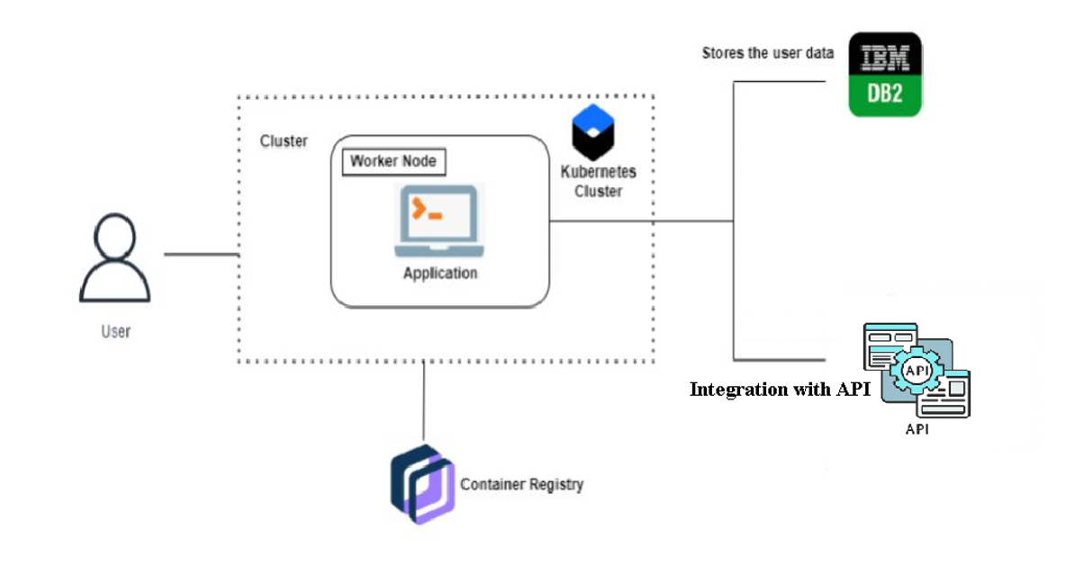

**RESULTS :**

